ANNEXURE – A List of Creditors

Financial Creditors
(Amount in INR)
Sr.  No. | Name of Creditor | Amount Claimed | Amount Provisionally Admitted* | Voting rights (%) | Secured/  Unsecured
1 | Axis Bank Limited | 769,386,824 | 769,386,824 | 45.70% | Secured
2 | IDBI Bank Limited | 581,490,795 | 581,202,697 | 34.52% | Secured
3 | State Bank of India | 259,091,932 | 259,091,932 | 15.39% | Secured
4 | Bank of India | 73,999,899 | 73,999,899 | 4.40% | Secured
 | Total | 1,683,969,449 | 1,683,681,352 | 100.00%
* As the Information requested from financial creditors for verification is awaited due to which amount claimed is provisionally admitted.

Operational Creditors (Government Dues):

(Amount in INR)
Sr. No | Government | Amount claimed | Amount of claim admitted
1 | Maheshwari Maji, CGST & CX, Division -III. | 183,652,488 | Under Verification
2 | Employees' State Insurance Corporation | 1,434,718

Operational Creditors (Employee):

(Amount in INR)
Sr. No | Name of employee | Amount claimed | Total amount of claim admitted
1 | Shankar Hansdah | 81,053 | Under verification
2 | Bidesh Maity | 334,853
3 | Debashish Mohanta | 466,412 | 466,312
4 | Prakash chandra | 311,121 | Under verification
5 | D. Ravi Shankar Rao | 218,881
6 | Raghbendra Pandey | 325,409
7 | Sukant Samal | 280,596
8 | Anil Pani | 55,388
9 | Shamsher Bahadur Singh | 83,906
10 | Pramod Kumar | 345,574
11 | Kwaljeet Singh | 307,443
12 | Pradyumna Bisoi | 39,112
13 | Ravi Prakash Tiwary | 165,418
14 | Pankaj Kumar | 205,805
15 | Anup Baidyanath Ash | 568,912

Operational Creditors (Workmen)

(Amount in INR)
Sr. No | Name of workman | Amount claimed | Total amount of claim admitted
1. | Uma Shanakr Singh | 6704 | Under verification
2. | Mantosh Kumar | 155,390
3. | MD Shahidul Islam | 44,424
4. | Tushar Kumar Padhy | 12,525
5. | Rabindra Nath Mahato | 62,703
6. | Fakir Mohan Das | 314,375
7. | Rajeeb Kumar Das | 72,410
8. | Yamanoorgouda Patil | 24,332
9. | Manash Ranjan Das | 410,703
10. | Sana Venkata Shailesh | 259,010

Operational Creditors (other than Workmen, Employees and Government Dues):

(Amount in INR)
Sr. No. | Name of creditor | Amount claimed | Amount Provisionally Admitted
1 | Abhijaat Singh Associates | 429,131 | Under Verification
2 | ABI Testing | 612,864
3 | ABI Testing | 393,335
4 | Adhir Enterprises | 795,795
5 | Advanced Machine Tools Pvt. Ltd. | 1,160,160
6 | Allahabad Silica Sand | 848,923
7 | Amar Enterprises | 2,149,414
8 | Anand Das | 178,866
9 | Anand Traders | 81,993
10 | Anand Utilities Pvt. Ltd. | 128,486
11 | APG Automation Pvt. Ltd | 7,878
12 | Arihant Corporation | 118,357
13 | Arun Kumar Singh | 53,556
14 | Arun Kumar Singh & Brothers | 9,376,529
15 | Aryan Enterprises | 553,447
16 | Ashapura International Limited | 392,430
17 | Ashiana Fuel and Service Centre | 36,994
18 | ASK Chemicals India Pvt. Ltd. | 290,266
19 | Atharva Enterprises | 2,166
20 | Atop Products Private Limited | 1,540,090 | 1,046,449
21 | B S Enterprises | 192,122 | Under Verification
22 | B. S Engineering | 6,851,587
23 | B.K Enterprises | 21,764
24 | Badri Prasad Amar Nath | 3,127,398
25 | Baker Gauges India Pvt. Ltd. | 176,029
26 | Balwainder Singh | 1,824,826
27 | Batohi Jha | 2,802,133
28 | Bhagirathi Transport Services | 412,201
29 | Bhanu Enterprises | 763,282
30 | Bharath Swift Logistics Pvt Ltd | 320,973
31 | Bharoti Industrial Suppliers | 136,043
32 | BIJAY SINGH SARDAR | 381,627
33 | Binod Kumar Rai | 186,130
34 | Bluedart Express Ltd. | 25,178
35 | Bluewin Facility Services | 10,325
36 | C B Management Services (P) ltd | 182,444
37 | Calcutta Compressions and Liquefaction Engineering Limited | 399,592
38 | Caprixa Control | 182,513
39 | Carl Zeiss India (Bangalore) Pvt. Ltd. | 159,101
40 | Ceramics India | 6,935,494
41 | CNC Ballscrews & Bearing Co.Pvt.Ltd | 99,939
42 | Control Scientific Works | 10,030
43 | Dina Nath Yadav | 236,861
44 | DMG Mori India Pvt. Ltd | 375,045
45 | DTR Corporation | 1,021,379
46 | E Electrika | 180,529
47 | Effective Marketing Pvt. Ltd. | 439,431
48 | Elements Corporation | 61,147
49 | Foundry Craft
50 | Gamaria Gas Service | 50,644
51 | Gargi Hüttenes-Albertus Private Limited | 737,230 | Under Verification
52 | Ghosh Enterprise | 151,259
53 | Global Technology | 601,597
54 | Glory Electric Concern, | 293,903
55 | Goutam Machine Tools | 116,023
56 | Goyal Enterprises | 620,543
57 | GP Petroleums Ltd. | 2,521,944
58 | GR Polynets | 84,636
59 | Grand Polycoats Co. Pvt. Ltd. | 12,503
60 | Grewal Lifters | 64,524
61 | GS Enterprise | 1,657
62 | Guria Enterprises | 186,110
63 | Hardcastle Petrofer Pvt Ltd | 863,328
64 | Hi Tech Services | 442,923
65 | HINDUSTAN POLYPACKS | 64,421
66 | Hira Electricals | 223,333
67 | HI-TECH TOOLINGS | 1,429,228
68 | Hydro Chemtech Private Limited | 53,710
69 | Incos India | 51,140
70 | Indian Forging & Stamping Co. (P) Ltd. | 667,054
71 | Industrial Protection force | 373,028
72 | informatrix | 57,073
73 | Instac Pneumatics & Services | 12,661
74 | ITL Industries Ltd. | 584,078
75 | J P Steel Udhyog | 947,039
76 | Jasbir Singh | 950,559
77 | Jharkhand Bijli Vitran Nigam Limited | 7,268,041
78 | Jinendra Industrial Products | 17,936
79 | Jkay Enterprises | 237,341
80 | JSD Global Steels | 163,525
81 | K G Sales Corporation | 602,163
82 | K.s.Enterprises | 142,683
83 | Kalipado Singh Sardar | 1,011,694
84 | Kemi Diesel Equipments | 390,183
85 | Kishore Engineering | 151,443
86 | Kumar's | 542,094
87 | Lubro air engineers p. ltd.
88 | M.K. Engineering Works | 194,844
89 | M/s Jinendra Industrial Products | 17,936
90 | M/S Kamla Kanta Das | 48,821
91 | M/S S. C. Bose | 1,831,652
92 | M/s S. D. Engineering | 12,380
93 | Maa Enterprise | 286,692
94 | Maa Sharda Endeavor Pvt Ltd | 5,793,818
95 | Magnatherm Alloys Pvt Ltd | 361,107
96 | MAHADEV ENTERPRISE | 16,696
97 | Mahindra Sanyo Special Steel Pvt.Ltd. | 177,285
98 | Malleshi Light Decorators | 1,130,145
99 | Manorama Enterprises | 4,370,377
100 | Manpreet Enterprise | 3,590,510
101 | Manu Kumar Sahi
102 | MD Alam Enterprise | 8,260
103 | MD Moqueem Uddin | 17,933
104 | Mehta Tools | 2,186,595
105 | Metcut Toolings Pvt Ltd | 308,659
106 | Micro Electricals | 180,598
107 | Modi Sales Agency | 68,970
108 | MR & Associates | 5,310
109 | Mritunjay Kumar ray | 48,624
110 | MSK Industries & Products Pvt. Ltd. | 59,266
111 | Mukesh & Yogendra Enterprises | 493,966
112 | Nabila Enterprise | 319,492
113 | Nafdist Pvt. Ltd. | 72,147
114 | Narendra Forge | 2,768,929
115 | NATIONAL GAS AGENCIES | 208,331
116 | Navya Enterprises | 40,036
117 | Neetu Kumari | 19,760
118 | Nikhil Hardware & Tools Co. | 89,376 | Under Verification
119 | Nishant Travels | 223,785
120 | O. P. Construction | 2,864,091
121 | Oerlikon Balzers Coating India Pvt. Limited | 335,156
122 | Omega Furnaces Pvt Ltd | 5,130
123 | Omkara Traders | 949,964
124 | Oneteck Automation Pvt. Ltd | 17,898
125 | P.S ENTERPRISES
126 | PACKWAY | 177,508
127 | Parmeswar Steel Industries | 763,191
128 | Precision Engineering Tools Corporation | 18,821
129 | Prime Technologies | 150,023
130 | PROLINE ENGINEERS | 20,595
131 | Pursales | 108,618
132 | Quaker Chemical India Pvt Ltd
133 | Quality Austria Central Asia Private Limited | 133,576
134 | R T Enterprises | 32,273
135 | Raj Auto & Engg. Industry | 657,557
136 | Raj Welds & Tools | 737,544
137 | Rajesh Metal Mfg Co | 129,777
138 | Rajesh Mishra | 197,762
139 | Ranjit Bhullar | 69,470
140 | Ranjit Singh | 69,470
141 | Relation Advertising | 156,933
142 | Reliable Roadlines Private limited | 66,458
143 | RK Enterprises | 38,082
144 | RN Mahato | 64,913
145 | Rustoppers Packtech Pvt Ltd
146 | Rustoppers Packtech Pvt. Ltd. | 20,650
147 | S Khurana & Associates | 47,200
148 | S P Enterprises | 119,695
149 | S S Enterprises | 453,169
150 | S. K Enterprises | 70,744
151 | Safe & Secure Logistics Pvt.Ltd. | 71,663
152 | Sahara Enterprises | 77,880
153 | Salts And Chemicals Pvt Ltd | 78,148
154 | Samir Kumar Ghosh | 174,483
155 | Sanatan Singh Sardar | 398,723
156 | Sandhya Rai | 369,122
157 | SAP India Private Limited | 2,513,650
158 | Satyam Enterprises | 1,399,043
159 | Shanti Enterprises | 4,733,632
160 | Shashi kant | 834,776
161 | Shiva Enterprises | 417,843
162 | Shiva Light Decorators | 1,130,145
163 | Shiv-Raj Calibration And Technical Services | 287,262
164 | Shree Ganesh Engineering | 222,884
165 | Shree Ram Transport Corporation | 107,908
166 | Shri Laxmi Venkateshwara Enterprises | 52,628
167 | Sidheshwar Yadav | 47,568
168 | Singhdeo Enterprises | 1,328,169
169 | SIS Limited | 5,526,879
170 | Size Masters Guages & Tools | 421,698
171 | SKB Exports | 237,552
172 | SR Engineering | 190,685
173 | SRI LAXMI PLASTIC | 169,630
174 | SRI PADO MAHATO | 32,603
175 | Srinath Appanna Gurav | 48,985
176 | SRS Metallurgical & Services | 36,580
177 | SS Hydraulics | 37,047
178 | SSR Traders & Carriers | 396,213
179 | Star Electricals | 64,356
180 | Subedar Engineering Works | 25,876
181 | Sukhwinder Singh | 364,026
182 | Suman Raj | 326,725
183 | Suman Sharma | 195,856
184 | Sunilkumar Printing Press | 25,592 | Under Verification
185 | Superchem Industrade | 418,580
186 | Superchem Industrade | 418,580
187 | Supreme Petro Chemicals | 5,161,365
188 | Systems & Controls | 183,195
189 | TARAMA ENGINEERING | 28,815
190 | Tarun Tools Pvt. Ltd | 3,566,250
191 | Tata Steel Long Products Limited | 790,760
192 | Techno Stamping and Pressing Industries | 82,357
193 | Techno Wiz | 305,054
194 | Tools And Hardware Centre/Dipesh N Mehta | 117,648
195 | Trade Link | 558,802
196 | Trade link | 548,882
197 | TÜV SÜD South Asia Pvt Ltd | 168,180
198 | TUV SUD South Asia Pvt. Ltd. | 120,124
199 | Veripro Sales and Services | 468,841
200 | Viay Laxmi Industries | 28,822
201 | Vijaylaxmi Industries | 30,696
202 | Vinayak Y Kadam | 222,848
203 | Viresh Engg & Consultants | 353,348
204 | Viscotec Solutions | 182,018
205 | Vyana Laser | 10,620
206 | Zeta India Inc | 767,570
207 | Del Star Enterprises | 57,207
208 | U R Associates | 59,077
209 | Quality Tool enterprises | 426,282
210 | Foseco India Limited | 374,859
211 | Alam Enterprises | 90,555
212 | Suyash Solutions Pvt Ltd | 47,200
213 | Vivek Trading Co | 3,497,725
214 | Jayaswal Neco Industries Limited | 5,908,956
215 | Samvardhana Motherson Innovative Solutions Ltd | 119,323
216 | Samvardhana Motherson Innovative Solutions Ltd | 46,518

ANNEXURE – B Security Interest

Details of Securities provided by Axis Bank Ltd in its claim form

First charge on entire current assets, both present & future, on pari-passu basis with other WC bankers in the multiple banking arrangement.

Second charge on entire Fixed Assets both current & future on pari-passu basis with other working capital bankers in the multiple banking arrangement.

Goods procured under LC.

Any other security offered to other working capital bankers will also be applicable.

Details of Securities provided by IDBI Bank Ltd in its claim form

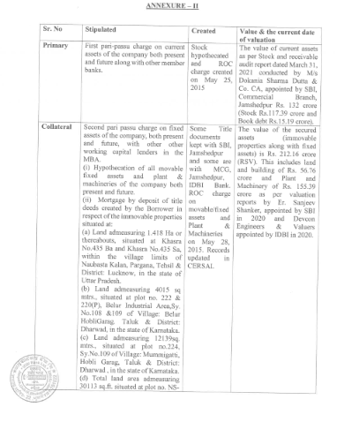

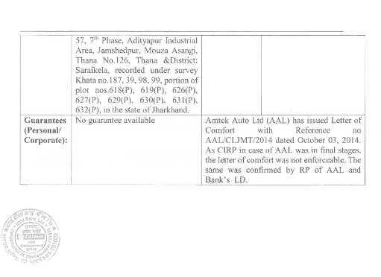

Details of Securities provided by State Bank of India in its claim form

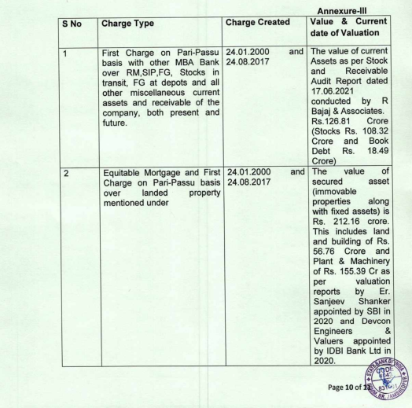

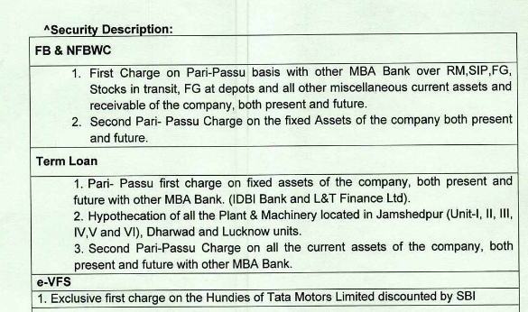

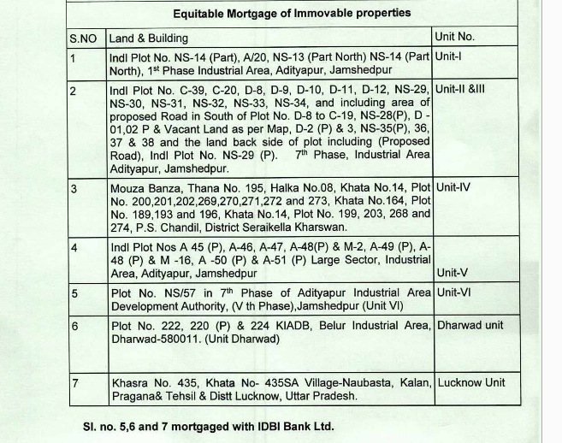

Details of Securities provided by Bank of India in its claim form

Primary: Pari-passu first charge on Current Assets, present and future and pledge of Term Deposits as Cash Margin in LC & BG.

Collateral: Pari-passu second charge on entire Fixed Assets. Exclusive Hypothecation charge on Plant & Machineries purchased out of their bank finance.

